Project briefs

# Film review website

I want a website that lets users review films. I’m a big fan of films myself. I’d like to add a description of the film myself to get the ball rolling, and then let other users add their reviews about that film. So we would end up with each film having a page of some sort that listed all the reviews. I’d also like pages about actors and directors, which would link to all the films they had appeared in or made. I’d like users to be able to add comments about the actors and directors, too.

I’d like users to be able to reply to each other’s comments, too. But I’d also like to be able to moderate and delete user comments, and block users who make too many out of order comments, as well.

I’d like each review to have a “marks out of ten”, too, so that there’s a league table of films that you can use to see the most / least popular.

I’d also like people to be able to tag films by their genre (action, thriller, comedy etc.), and then use those tags to be able to filter the best / worst tables (so you could list “the worst comedies”).

Plus I’d like people to be able to add film news stories, gossip etc.

**Example:**

<http://www.rottentomatoes.com/>

<http://www.imdb.com/>

<http://www.zergnet.com/>

# Identify use cases:

**Admin -**

+ Login

Add Film Description

+ Add Gossip Page

+ Add Actor/Director Page

(Moderate) Update comments

Delete comments

(Block) Suspend User

**User -**

+ Add User

+ Login

Add Review (of film)

Tag Film Genre (can tag film genres not actors/directors)

Rate Review (of film out of 10)

Add Comment (of actors + directors)

Reply Comment

+ List Film

Add Gossip

# Identify candidate classes

Film

Review

Comment

+ Credits (Base)

Actor (Inherited)

Director (Inherited)

+ Admin

User

League table? (Of best/worst comedies)

Gossip Page (Of film with list of its reviews)

Genre?

# Use cases

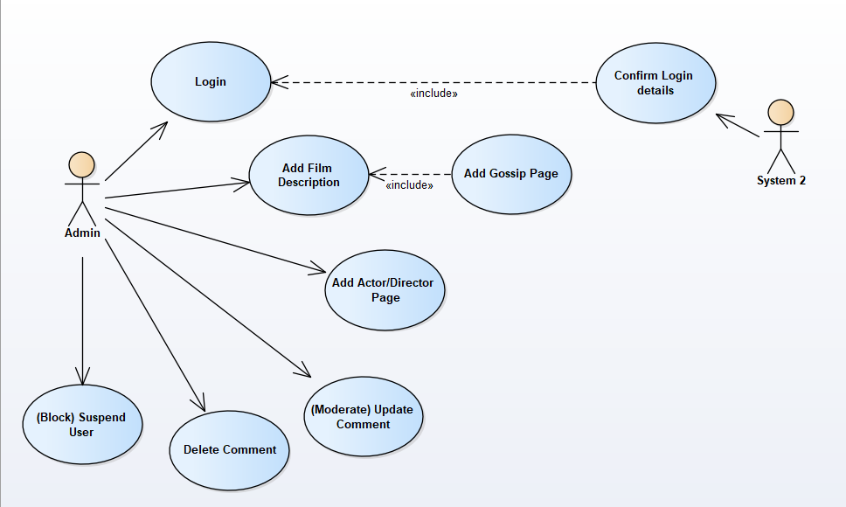

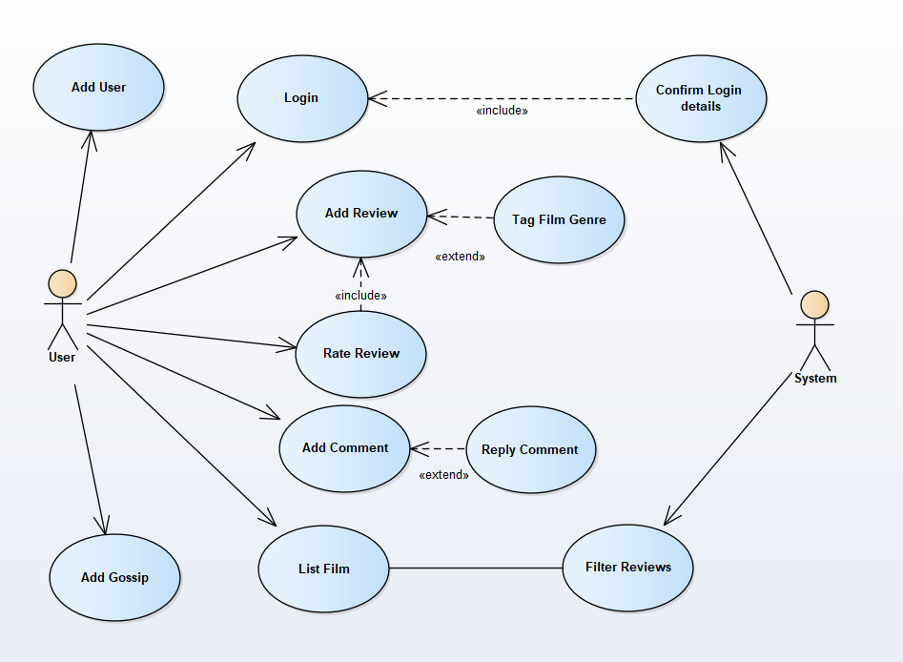

Rate Review ‘includes’ Add Review because Admin said its part of (so would be an attribute of) the Review Class

# Class Diagram

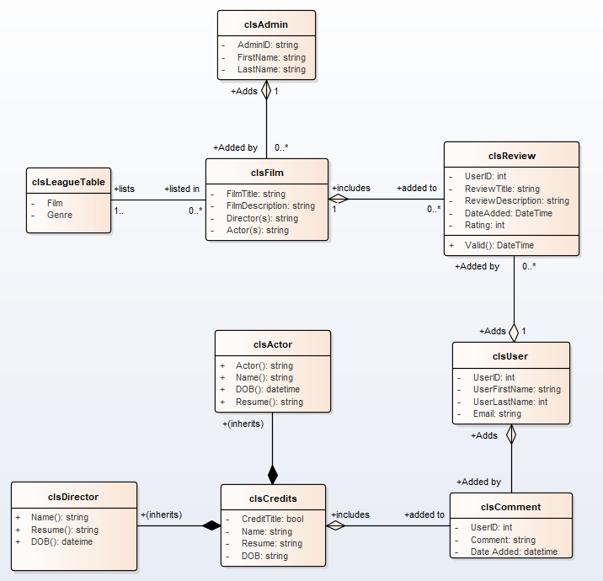

I thought Actor and Director attributes are the same so might be inherited classes of Credits (base class) + Salim said something about using polymorphism + thought here is probably where it is appropriate + tried keeping classes as simple as possible